SHOW RESULTS – SHOW 1  CLUB: Feline Fan Club (FFC)  DATE: 15 June 2013  VENUE: Batter Boys, Montana  SPONSOR: Royal Canin | BEST IN SHOW:  Pearl Caramello Koala  Burmese Chocolate  Bred and owned by P Steyn

PERSIAN/EXOTIC:  Best Kitten & Best of Breed:  L’Exquisite Incroyable  Exotic Classic Tabby Black Tortoiseshell  Bred / owned by B Neukircher  Best Neuter:  Cracker Unbelievable  Persian Self Black  Bred by A Visser & P Williams  Owned by R van Wyk  Best Female:  Brettachtal’s Miss South Africa of The Catwalk  Persian Silver Shaded Black  Bred by K Sinn / Owned by S Marsh  Best Male:  Brettachtal’s Maserati of The Catwalk  Persian Silver Shaded Black  Bred by K Sinn / Owned by S Marsh | SIAMESE/ORIENTAL:  Best Female & Best of Breed:  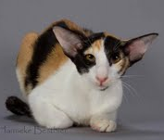  LaMaska She of Seven Veils  Oriental Bicolour Black Tortoiseshell  Bred / owned by M Burger  Best Kitten:  Siamese Gardens Isabella  Siamese Tabby Pointed Seal  Bred / owned by D Graaff  Best Neuter:  LaMaska Othello  Oriental Smoke Black  Bred by M Burger  Owned by R Smith  Best Male:  No nominations | FOREIGN:  Best Kitten & Best of Breed & Best in Show:  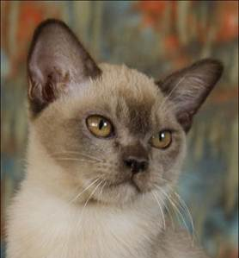  Pearl Caramello Koala  Burmese Chocolate  Bred / owned by P Steyn  Best Female:  Kisamee Delfi  Cornish Rex Bicolour Blue Tortoiseshell  Bred / owned by N Strydom  Best Neuter:  Kisamee Damon Salvatore  Cornish Rex Bicolour Black  Bred / owned by N Strydom  Best Male:  RS*Rextasy Wanna Dance? Of Kisamee  Cornish Rex Bicolour Black  Bred by M Rancic  Owned by N Strydom | MEDIUM HAIR:  Best Female & Best of Breed:  Picture to follow  Colorkats Just Perfect  Maine Coon Classic Tabby Bicolour Black  Bred / owned by D le Roux  Best Kitten:  Colorkats Leo  Maine Coon Classic Tabby Bicolour Black  Bred / owned by D le Roux  Best Male:  Zack Nova Axis Star, CZ of Shangri-La  Maine Coon Mackerel Tabby Bicolour Black  Bred by W Choulikova  Owned by V Wright  Best Neuter:  Colorkats Key West  Maine Coon Classic Tabby Bicolour Black  Bred / owned by D le Roux

BEST PET:  Yuki  Shorthair Black  Owned by S Venter | 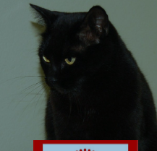 | TRIPLE SUPREME CHALLENGE:  Entire  Tres Jolie Sweet Taboo  Owned by C Danziger | TRIPLE SUPREME CHALLENGE:  Neuter  Tres Jolie Bella Donna  Owned by C Danziger | VETERAN CHALLENGE:  Entire  Brettachtal’s Aida of The Catwalk  Owned by S Marsh | VETERAN CHALLENGE:  Neuter  Flamboyant Alvin L’Meur  Owned by R van Wyk | SUPER PET CHALLENGE:  Tinkerbell  Owned by J May

