SHOW RESULTS – SHOW 1  CLUB: Feline Fan Club (FFC)  DATE: 30 March 2013  VENUE: Discovery Recreation Centre  SPONSOR: Royal Canin | BEST IN SHOW:  Kisamee Delfi  Cornish Rex Bicolour Blue Tortoiseshell  Bred and owned by N Strydom

PERSIAN/EXOTIC:  Best Kitten, Best of Breed and BIS:  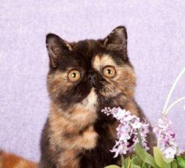  L’Exquisite Incroyable  Exotic Classic Tabby Black Tortoiseshell  Bred / owned by B Neukircher  Best Neuter:  Cracker Unbelievable  Persian Self Black  Bred by A Visser & P Williams  Owned by R van Wyk  Best Female:  ShakesPURR As It Is  Persian Tabby Harlequin Blue Tortoiseshell  Bred / owned by H Rohrs  Owned by S Marsh  Best Male:  Ixidixi Brownie of L’Exquisite  Exotic Classic Tabby Black  Bred by Persson/Cyrillus  Owned by B Neukircher | SIAMESE/ORIENTAL:  Best Male & Best of Breed:  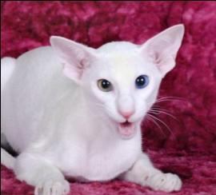  LaMaska Aurora Borealis  Oriental Self White Odd-eye  Bred / owned by M Burger  Best Kitten:  Siamese Gardens Murdock  Siamese Pointed Seal  Bred / owned by D Graaff  Best Neuter:  LaMaska Othello  Oriental Self Black  Bred by M Burger  Owned by R Smith  Best Female:  LaMaska She of Seven Veils  Oriental Bicolour Black Tortoiseshell  Bred / owned by M Burger | FOREIGN:  Best Female& Best of Breed & Best in Show:  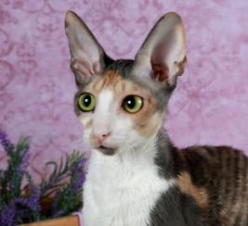  Kisamee Delfi  Cornish Rex Bicolour Blue Tortoiseshell  Bred / owned by N Strydom  Best Kitten:  Spandau Vulcan  Sphynx Bicolour Chocolate Mink  Bred by W Hyman  Owned by S Fitz-patrick & A van Doornum  Best Neuter:  Kisamee Damon Salvatore  Cornish Rex Bicolour Black  Bred / owned by N Strydom  Best Male:  RS*Rextasy Wanna Dance? Of Kisamee  Cornish Rex Bicolour Black  Bred by M Rancic  Owned by N Strydom | MEDIUM HAIR:  Best Male & Best of Breed:  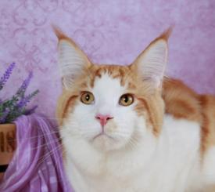  Shangri-La Asani Rebel  Maine Coon Mackerel Tabby Bicolour Red  Bred / owned by V Wright  Best Kitten:  Geedee Lilac Dawn  Norwegian Forest Cat Harlequin Blue Tortoiseshell  Bred / owned by A Caw  Best Female:  Swagger Coons My Lady Soul  Maine Coon Classic Tabby Black  Bred / owned by N & S Prinsloo  Best Neuter:  Westwood Skyhawk  Maine Coon Mackerel Tabby Bicolour Black  Bred / owned by G Nel

BEST PET:  Miss Marilyn Monroe  Longhair Blue Bicolour  Owned by L Moodley & S Singh | 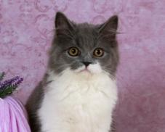 | TRIPLE SUPREME CHALLENGE:  Entire  Jalbertus Alexander McQueen of The Catwalk  Owned by S Marsh | TRIPLE SUPREME CHALLENGE:  Neuter  Fancy Face Morrigan  Owned by S Fitz-patrick & A van Doornum | VETERAN CHALLENGE:  Entire  Ixidixi Brownie of L’Exquisite  Owned by B Neukircher | VETERAN CHALLENGE:  Neuter  Flamboyant Alvin L’Meur  Owned by R van Wyk | SUPER PET CHALLENGE:  Tinkerbell  Owned by J May

